**[Project Title]**

**Research Report I**



**Supervisor**

[Supervisor Name]

**Submitted by**

[Student Name]

[AG #]

**BS [Computer Science/IT/Software Engineering]**

**Department of Computer Science**

**University of Agriculture, Faisalabad.**

Table of Contents

**1.** **INTRODUCTION** 1

**1.1 Background** 1

**1.2 Description** 1

**1.3 Scope** 1

**1.4 Objectives** 2

**2.** **REQUIREMENTS** 2

**2.1 Functional Requirements** 2

**2.2 Non- Functional Requirements** 2

**2.3 Hardware Requirements** 3

**2.4 Software Requirements** 3

**3.** **METHODOLOGY** 3

**3.1 Tools & Technologies** 4

**4. TIMELINE** 4

List of Figures

**Figure 1: RAD Activities**  3

**Figure 2: Tentative Timeline of the Project activities**  4

List of Tables

**Table 1: Caption of the table** 3

# **INTRODUCTION**

## **1.1 Background**

A background of a project is just a simple and short statement of the project, meaning why we need to initiate it and what problems and needs will be addressed once it’s been implemented successfully. The purpose of the background is to give an overview of the project for deciding on the need to do the project and for initiating the planning process. When you write a background for your project your primary focus should be placed on giving a general idea and explaining the key prerequisites.

## **Description**

A description of a project is a narrative containing a more detailed explanation of the project’s goals and objectives, the definition of the business needs and problems to be addressed, potentials pitfalls and challenges, implementation methods and approaches to be applied, people and organizations interested in and/or impacted by the project. The purpose of the description is to create a foundation for further development and implementation of the project. When you develop a description you should use accurate and specific information to explain the objectives, desired outcome and implementations methods of your future project.

## **1.3 Scope**

Project scope is the work that needs to be accomplished to deliver a product, service, or result with the specified features and functions. Scope Plays a Vital Role in Projects. "Scope" includes the expected work effort and results for a given project, and must be documented and accepted before the project begins. A well-written scope statement is crucial to a project. You create a project scope statement to establish a solid agreement between the project team and the customer by clarifying, identifying, and relating the work of the project to the business owner's objectives.

## **1.4 Objectives**

Goals and objectives define what has to be done.  A goal is simply a broad statement of what you want to do. The objectives are sub-goals, more detailed, that explain what must be done to achieve the goal. Your project should have only one goal, but may have several objectives.

* Goal (more broad): We want to move the office to Houston, Texas.
* Objective (more specific): Locate an office in Houston.
* Objective (more specific): Arrange for personnel and equipment transfer
* Objective (more specific): Transfer equipment and furnishings

# **REQUIREMENTS**

## **2.1 Functional Requirements**

Any requirement which precisely specifies what the system should do is called functional requirement of the system. In other words, a functional requirement will describe a particular behavior of function of the system when certain conditions are met, for example: “Send email when a new customer signs up” or “Open a new account”.

(Write down all functional requirements of your system in the format given below. Given is an example :)

### FR01: Provide user name and password to log in

|  |  |
| --- | --- |
| FR01-01 | System shall get Username and Password from user |
| FR01-02 | System should authenticate user name and password |
| FR01-03 | System shall let the user to log in if information is valid |
| FR01-04 | If information is not valid then system will display message to get the account by admin |

### FR02: Create user account

|  |  |
| --- | --- |
| FR02-01 | System shall allow admin to create accounts for faculty members |
| FR02-02 | System shall collect necessary details in this regard. |

## **2.2 Non- Functional Requirements**

Any requirement which specifies how the system performs a certain function is called non-functional requirement. In other words, a non-functional requirement will describe how a system should behave and what limits there are on its functionality. Non-functional requirements generally specify the system’s quality attributes or characteristics, for example: “Modified data in a database should be updated for all users accessing it within 2 seconds.” Typical non-functional requirements include: Performance – for example: response time, throughput, utilization, static volumetric, Scalability, Capacity, Availability, Reliability, Recoverability, Maintainability, Serviceability, Security, Regulatory, Manageability, Environmental, Data Integrity, Usability, Interoperability

**NFR01:** System shall remain available 24/7 to its users.

**NFR02:** System shall have two types of users i.e., admin and client.

**NFR02:** System shall provide tooltip for every option/button.

## **2.3 Hardware Requirements**

(List minimum hardware requirement to run your project on user’s side. Below is the hardware requirement example for a website)

Processor: Pentium(R) Core i3 CPU or more

Hard Disk: 40GB or more

RAM: 256MB or more

## **2.4 Software Requirements**

(List minimum software requirement to run your project on user’s side. Below is the software requirement example for a website)

Operating System: Windows10, Windows 8.1, Windows 8, Windows 7

Browser: Google Chrome, Firefox, Mozilla etc.

# **METHODOLOGY**

(Describe the significance of process model you choose. For example: if we Chose RAD then briefly describe about its significance and how RAD fits with your project) RAD model is Rapid Application Development model. It is a type of incremental model. In RAD model the components or functions are developed in parallel as if they were mini projects. The developments are time boxed, delivered and then assembled into a working prototype. This can quickly give the customer something to see and use and to provide feedback regarding the delivery and their requirements.

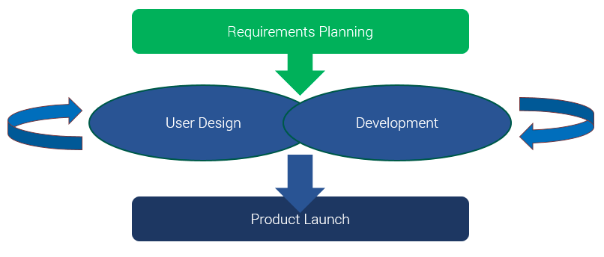

Figure 1: RAD Activities

Table 1: (if any table is to add) Table caption goes here

|  |  |  |  |
| --- | --- | --- | --- |
| **Heading 1** | **Heading2** | **Heading 3** | **Heading 4** |
| Text | Text | Text | Text |
| Text | Text | Text | Text |

## **Tools & Technologies**

Briefly describe tools to be used in project development (one line each). For example: MS Visual Studio, NetBeans, PHP, Adobe Photoshop, MySQL etc.

# **4. Timeline**

(Use any online tool or MS Excel, MS Visio etc. to draw Gantt chart)

A Gantt chart is a timeline view that makes it easy to see how a project is tracking. You can visualize project tasks and see how they relate to each other as projects progress over time. Use this tool to simplify your tasks and details with a visual project timeline by transforming task names, start dates, durations, and end dates into cascading horizontal bar charts.

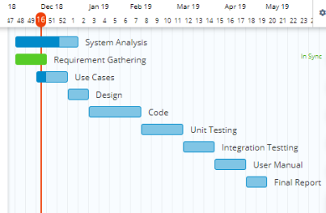

Figure 2: Tentative timeline of the project activities

INSTRUCTIONS:

Following formatting is already applied on the document. However, it is explicitly mentioned below:

* Font style : Times New Roman
* Paragraph font size: 12pt
* Main Heading Size: 14pt + Bold (before and after spacing 12pt)
* Sub Heading Size: 13pt + Bold (before and after spacing 8pt)
* Sub sub heading size 12pt + bold (before and after spacing 6pt)
* Paragraph Alignment: Justified
* Picture/Chart Alignment: Center
* Picture/chart/table heading font: Times New Roman
* Picture/chart/table heading font size: 10pt, Italic, center alignment
* Picture caption goes under the picture without any extra line and line space
* Table caption goes above the table without any extra line and line space
* Table heading: Times New Roman, 10pt, Bold
* Table text: Times New Roman, 10pt
* Line Spacing: 1.15
* Left/Right/Top/Bottom Margins: 1 inch
* Table of Contents, List of Tables, List of Figures Heading: Times New Roman. 14pt, Bold
* Table of Contents, List of Tables, List of Figures: Times New Roman. 12pt
* For Table of Contents, List of Tables & List of Figures use Roman number as page number format in footer (center align)
* For Introduction onwards, use integer number as page number format in footer (center align)